

Department of Computer Science and Engineering

Course Code: CSE302

Course Title: Database Systems

Section: 01

Semester: Fall 23

**LAB 03**

**Submitted to:**

**Dr. Mohammad Rezwanul Huq**

Associate Professor

Department of Computer Science and Engineering

East West University

**Submitted by:**

**Name:** B M Shahria Alam

**ID:** 2021-3-60-016

**Date of submission:** 28th October, 2023.

**Lab Task**

**# 01**

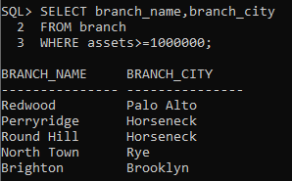

**# 02**

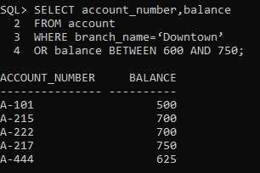

**# 03**

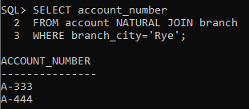

**# 04**

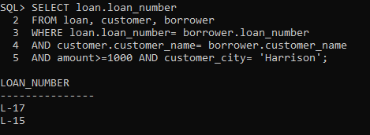

**# 05**

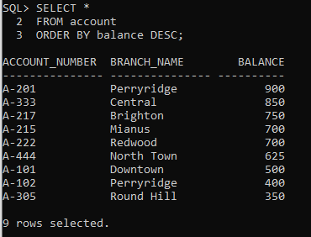

**# 06**

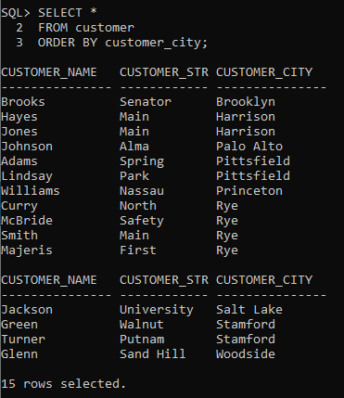

**# 07**

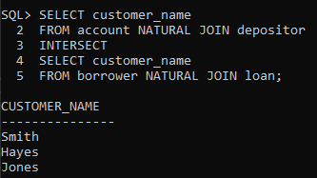

**# 08**

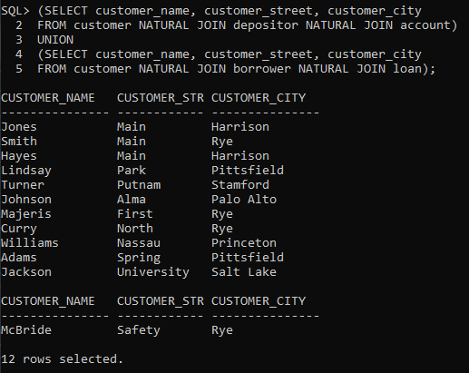

**# 09**

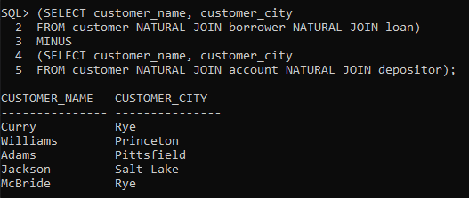

**# 10**

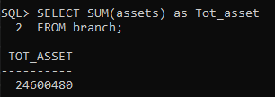

**# 11**

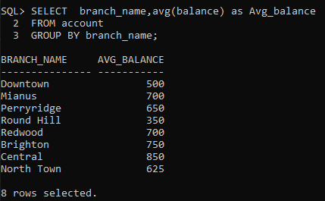

**# 12**

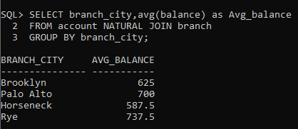

**# 13**

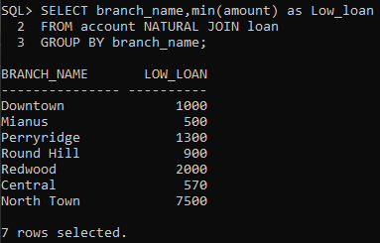

**# 14**

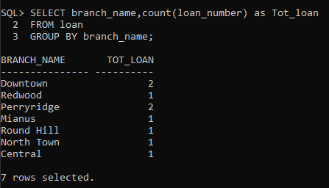

**# 15**

